Experiment – 11
Write a program for the task of Credit Score Classification

Aim
To implement a Credit Score Classification model using Machine Learning to classify customers into credit score categories (Good, Standard, and Poor) based on financial attributes.

Algorithm
- Import the required libraries.
- Load the credit score dataset.
- Select input features and target variable.
- Encode categorical data if necessary.
- Split the dataset into training and testing sets.
- Train a Random Forest Classifier.
- Predict the credit score class for test data.
- Evaluate the model using Accuracy, Confusion Matrix, and Classification Report.
- Predict the credit score for a new customer.

Program:
# Step 1: Import Libraries
import pandas as pd
from sklearn.model_selection import train_test_split
from sklearn.ensemble import RandomForestClassifier
from sklearn.metrics import accuracy_score, classification_report, confusion_matrix
from sklearn.preprocessing import LabelEncoder

# Step 2: Create Sample Dataset
data = {
'Age': [25, 40, 35, 28, 50, 30, 45, 38, 29, 55],
'Annual_Income': [40000, 80000, 60000, 45000, 100000, 50000, 90000, 70000, 48000, 110000],
'Loan_Amount': [5000, 10000, 7000, 6000, 15000, 8000, 12000, 9000, 6500, 18000],
'Credit_History': [3, 8, 6, 4, 10, 5, 9, 7, 4, 11],
'Credit_Score': ['Poor', 'Good', 'Standard', 'Poor', 'Good',
'Standard', 'Good', 'Standard', 'Poor', 'Good']
}

df = pd.DataFrame(data)

# Step 3: Encode Target Labels
encoder = LabelEncoder()
df['Credit_Score'] = encoder.fit_transform(df['Credit_Score'])

# Step 4: Split Features and Target
X = df[['Age', 'Annual_Income', 'Loan_Amount', 'Credit_History']]
y = df['Credit_Score']

# Step 5: Train-Test Split
X_train, X_test, y_train, y_test = train_test_split(
X, y, test_size=0.2, random_state=42
)

# Step 6: Train Random Forest Model
model = RandomForestClassifier(n_estimators=100, random_state=42)
model.fit(X_train, y_train)

# Step 7: Prediction
y_pred = model.predict(X_test)

# Step 8: Evaluation
print("Accuracy:", accuracy_score(y_test, y_pred))

print("\nConfusion Matrix:")
print(confusion_matrix(y_test, y_pred))

print("\nClassification Report:")
print(classification_report(
y_test,
y_pred,
target_names=encoder.classes_,
zero_division=0
))

# Step 9: Predict New Customer
new_customer = [[32, 75000, 8500, 7]]
prediction = model.predict(new_customer)

print("\nPredicted Credit Score:",
encoder.inverse_transform(prediction)[0])
Output:
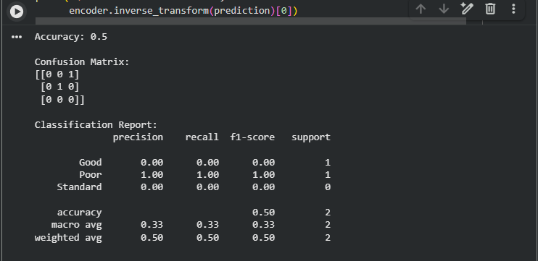

Result
The Random Forest Classifier successfully classifies customers into Good, Standard, and Poor credit score categories based on age, annual income, loan amount, and credit history. The model performance is evaluated using Accuracy, Confusion Matrix, and Classification Report, and it can also predict the credit score for new customer data.

